Sales Mangement System

- Odoo sale module is the most advanced sales managment system
- Odoo sales is the application to run your sales process (from quotation to sales order) and deliver and invoice what has been sold.

Product

To create product

Sales -> Products -> Create

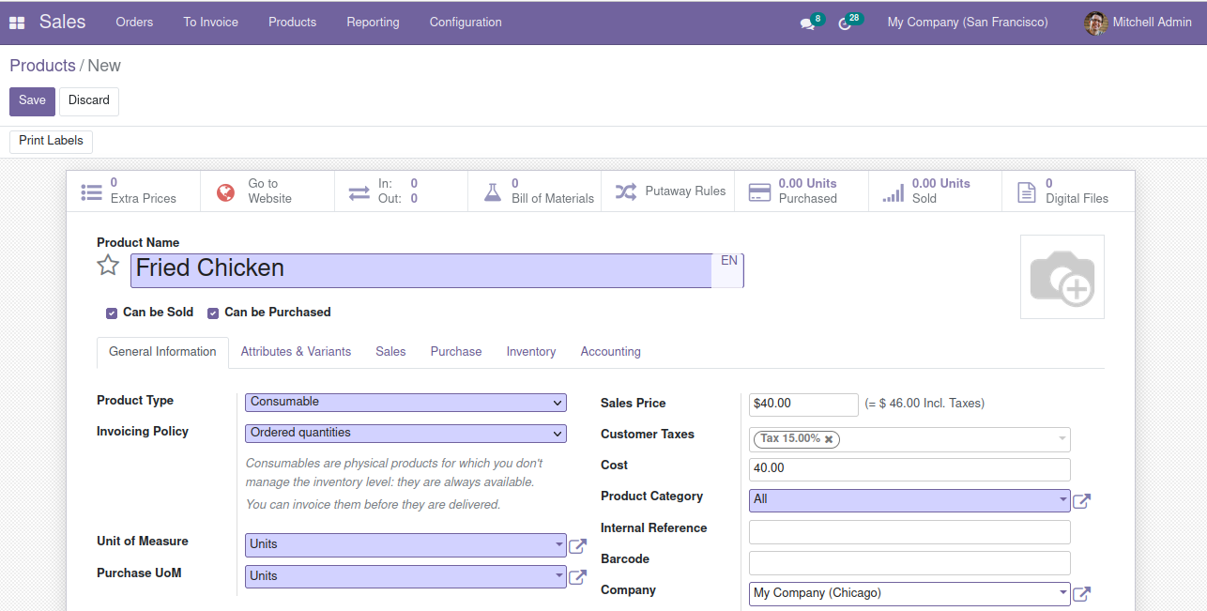

Customer

To create customer

Sales -> Orders -> Customers -> Create
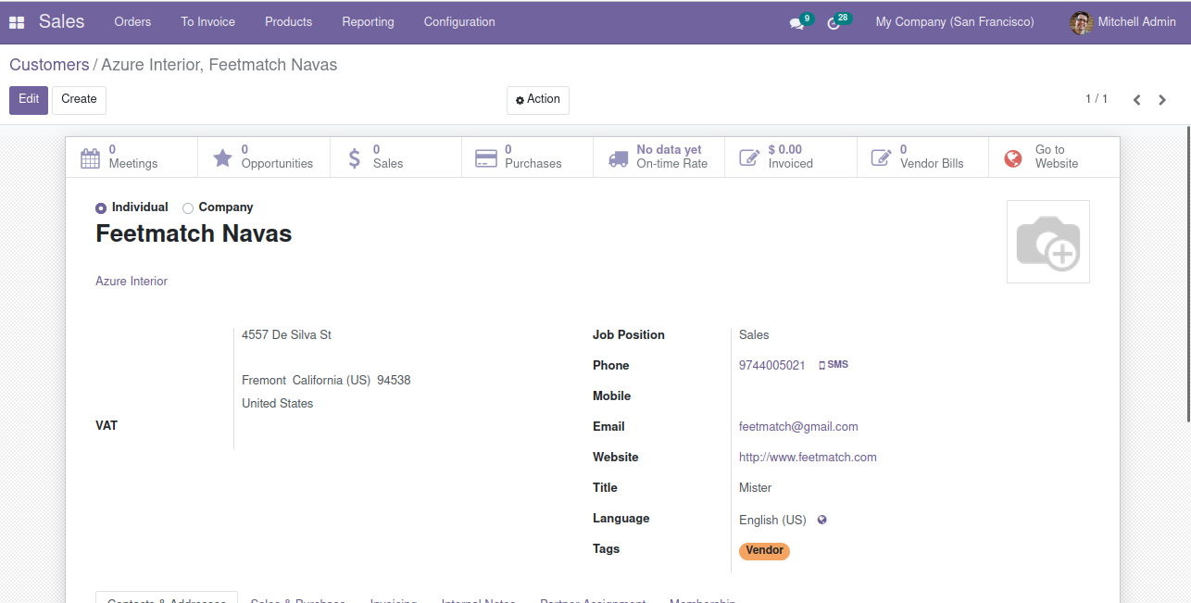

Sales

To create quotation

orders -> create quotation->

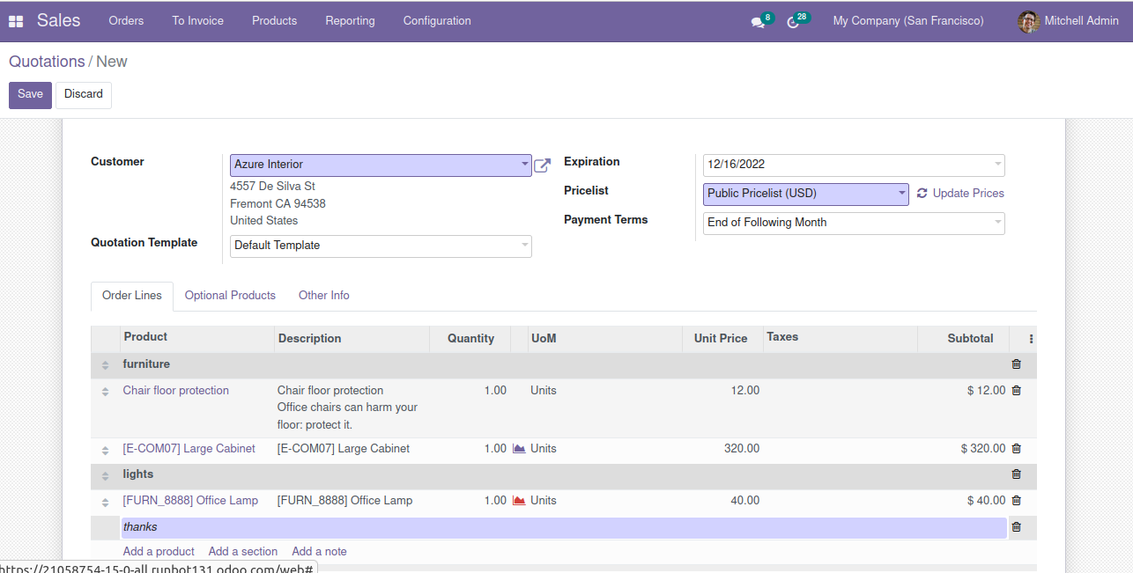

after confirming the quotation create sales order

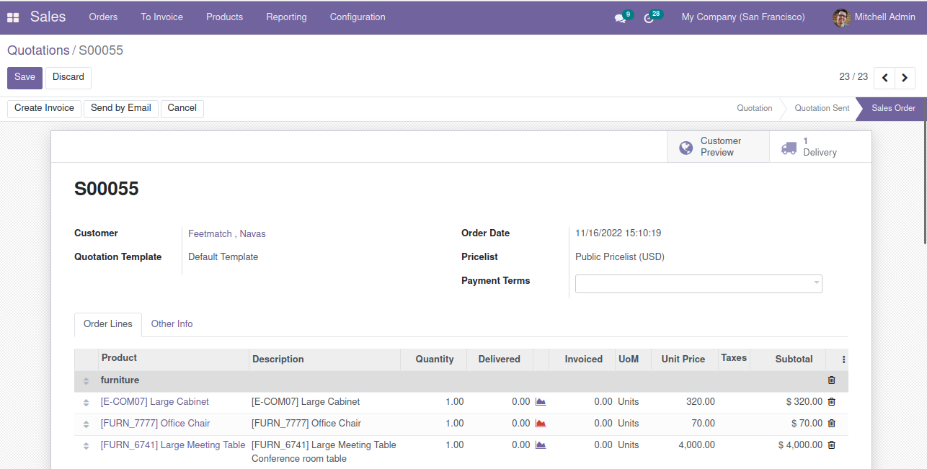

after creation of sale order we can create invoice

Sales:
Odoo sales is the application to run your sales process (from quotation to sales order) and deliver and invoice what has been sold.

To create quotation

orders -> create quotation->

after confirming quotation create sales order

